Supplementary material

Supplementary Table 1. The cross-sectional association between LAPI and prevalent LUTS/BPH (as a continuous variable).
Models | OR (95% CI) | p value
Model 1 | 1.004 (1.001–1.008) | 0.008
Model 2 | 1.006 (1.002–1.009) | 0.001
Model 3 | 1.005 (1.001–1.008) | 0.011
Model 4 | 1.004 (1.001–1.008) | 0.021
Model 5 | 1.007 (1.001–1.013) | 0.016
LAPI was used as a continous variable. Model 1—crude model; Model 2—adjusting for age, educational levels and marital status; Model 3—further adjusting for sleep duration, afternoon nap, cigarette and alcohol consumption; Model 4—further adjusting for hypertension and depression; Model 5—further adjusting for blood biomarkers including uric acid, LDL, BUN, HDL and total cholesterol.

Supplementary Table 2. The cross-sectional association between LAPI and prevalent LUTS/BPH after interpolation (as a continuous variable).
Models | OR (95% CI) | p value
Model 1 | 1.004 (1.001–1.007) | 0.008
Model 2 | 1.006 (1.002–1.009) | <0.001
Model 3 | 1.005 (1.001–1.008) | 0.007
Model 4 | 1.005 (1.001–1.008) | 0.009
Model 5 | 1.009 (1.003–1.015) | 0.004
The missing values were first interpolated using random forest method. Then, LAPI was used as a continous variable. Model 1—crude model; Model 2—adjusting for age, educational levels and marital status; Model 3—further adjusting for sleep duration, afternoon nap, cigarette and alcohol consumption; Model 4—further adjusting for hypertension and depression; Model 5—further adjusting for blood biomarkers including uric acid, LDL, BUN, HDL and total cholesterol.

Supplementary Table 3. The cross-sectional association between LAPI and prevalent LUTS/BPH after interpolation (tertiles).
Models | T1 | T2 OR (95% CI) | p value | T3 (95% CI) | p value | p for trend
Model 1 | 1.00 | 1.07 (0.82–1.39) | 0.631 | 1.36 (1.06–1.76) | 0.017 | 0.016
Model 2 | 1.00 | 1.08 (0.82–1.41) | 0.583 | 1.47 (1.13–1.91) | 0.004 | 0.003
Model 3 | 1.00 | 1.05 (0.80–1.38) | 0.716 | 1.36 (1.04–1.77) | 0.025 | 0.022
Model 4 | 1.00 | 1.07 (0.82–1.41) | 0.607 | 1.36 (1.03–1.79) | 0.030 | 0.029
Model 5 | 1.00 | 1.16 (0.87–1.54) | 0.315 | 1.59 (1.12–2.25) | 0.009 | 0.010
The missing values were first interpolated using random forest method. Then, LAPI was stratified according to the tertiles. The T1 group was used as the reference group. Model 1—crude model; Model 2—adjusting for age, educational levels and marital status; Model 3—further adjusting for sleep duration, afternoon nap, cigarette and alcohol consumption; Model 4—further adjusting for hypertension and depression; Model 5—further adjusting for blood biomarkers including uric acid, LDL, BUN, HDL and total cholesterol.

Supplementary Table 4. The longitudinal association between LAPI and incident LUTS/BPH in 2011–2018 cohort (as a continuous variable).
Models | OR (95% CI) | p value
Model 1 | 1.007 (1.004–1.011) | <0.001
Model 2 | 1.008 (1.004–1.011) | <0.001
Model 3 | 1.007 (1.004–1.011) | <0.001
Model 4 | 1.007 (1.003–1.011) | <0.001
Model 5 | 1.006 (1.0005–1.012) | 0.034
A total of 2855 males were followed up to 2018 years. LAPI was stratified according to the tertiles and used as continous variable in these regression models. Model 1—crude model; Model 2—adjusting for age, educational levels and marital status; Model 3—further adjusting for sleep duration, afternoon nap, cigarette and alcohol consumption; Model 4—further adjusting for hypertension and depression; Model 5—further adjusting for blood biomarkers including uric acid, LDL, BUN, HDL and total cholesterol.

Supplementary Table 5. The longitudinal association between LAPI and incident LUTS/BPH in 2011–2013 cohort.
Models | LAPI |  |  |  |  | p for trend
 | T1 | T2 OR (95% CI) | p value | T3 OR (95% CI) | p value
Model 1 | 1.00 | 1.46 (1.04–2.04) | 0.030 | 1.61 (1.15–2.26) | 0.005 | 0.006
Model 2 | 1.00 | 1.45 (1.03–2.04) | 0.032 | 1.64 (1.17–2.31) | 0.004 | 0.005
Model 3 | 1.00 | 1.38 (0.98–1.95) | 0.065 | 1.50 (1.06–2.13) | 0.021 | 0.023
Model 4 | 1.00 | 1.41 (0.99–2.00) | 0.058 | 1.42 (0.98–2.05) | 0.061 | 0.068
Model 5 | 1.00 | 1.40 (0.97–2.03) | 0.070 | 1.54 (0.98–2.43) | 0.063 | 0.059
A total of 3072 males were followed up to 2013 years. LAPI was stratified according to the tertiles and used as a categorical variable in these regression models. Model 1—crude model; Model 2—adjusting for age, educational levels and marital status; Model 3—further adjusting for sleep duration, afternoon nap, cigarette and alcohol consumption; Model 4—further adjusting for hypertension and depression; Model 5—further adjusting for blood biomarkers including uric acid, LDL, BUN, HDL and total cholesterol.

Supplementary Table 6. The longitudinal association between LAPI and incident LUTS/BPH in 2011–2013 cohort (as a continuous variable).
Models | OR (95% CI) | p value
Model 1 | 1.005 (1.001–1.009) | 0.015
Model 2 | 1.005 (1.001–1.010) | 0.010
Model 3 | 1.005 (1.0003–1.009) | 0.035
Model 4 | 1.004 (0.999–1.008) | 0.090
Model 5 | 1.011 (1.003–1.018) | 0.006
A total of 3072 males were followed up to 2013 years. LAPI was used as a continous variable in these regression models. Model 1—crude model; Model 2—adjusting for age, educational levels and marital status; Model 3—further adjusting for sleep duration, afternoon nap, cigarette and alcohol consumption; Model 4—further adjusting for hypertension and depression; Model 5—further adjusting for blood biomarkers including uric acid, LDL, BUN, HDL and total cholesterol.

Supplementary Table 7. The longitudinal association between LAPI and incident LUTS/BPH in 2011–2015 cohort.
Models | LAPI |  |  |  |  | p for trend
 | T1 | T2 OR (95% CI) | p value | T3 OR (95% CI) | p value
Model 1 | 1.00 | 1.42 (1.06–1.90) | 0.020 | 1.70 (1.28–2.27) | <0.001 | <0.001
Model 2 | 1.00 | 1.43 (1.06–1.92) | 0.018 | 1.78 (1.33–2.39) | <0.001 | <0.001
Model 3 | 1.00 | 1.39 (1.04–1.88) | 0.028 | 1.65 (1.23–2.23) | 0.001 | <0.001
Model 4 | 1.00 | 1.41 (1.04–1.90) | 0.028 | 1.59 (1.16–2.18) | 0.004 | 0.004
Model 5 | 1.00 | 1.39 (1.02–1.91) | 0.040 | 1.57 (1.06–2.31) | 0.023 | 0.022
A total of 2976 males were followed up to 2015 years. LAPI was stratified according to the tertiles and used as a categorical variable in these regression models. Model 1—crude model; Model 2—adjusting for age, educational levels and marital status; Model 3—further adjusting for sleep duration, afternoon nap, cigarette and alcohol consumption; Model 4—further adjusting for hypertension and depression; Model 5—further adjusting for blood biomarkers including uric acid, LDL, BUN, HDL and total cholesterol.

Supplementary Table 8. The longitudinal association between LAPI and incident LUTS/BPH in 2011–2015 cohort (as a continuous variable).
Models | OR (95% CI) | p value
Model 1 | 1.006 (1.003–1.010) | <0.001
Model 2 | 1.007 (1.004–1.011) | <0.001
Model 3 | 1.007 (1.003–1.010) | <0.001
Model 4 | 1.007 (1.003–1.011) | 0.001
Model 5 | 1.012 (1.005–1.018) | 0.001
A total of 2976 males were followed up to 2015 years. LAPI was used as a continous variable in these regression models. Model 1—crude model; Model 2—adjusting for age, educational levels and marital status; Model 3—further adjusting for sleep duration, afternoon nap, cigarette and alcohol consumption; Model 4—further adjusting for hypertension and depression; Model 5—further adjusting for blood biomarkers including uric acid, LDL, BUN, HDL and total cholesterol.

Supplementary Fig. 1. The dose-response association between LAPI and prevalent LUTS/BPH after interpolation. The missing values were first interpolated using random forest method. Then, restricted cubic spline regression was used to replicate the dose-response relationship between LAPI and prevalent LUTS/BPH. In the overall population (A), age, educational levels, marital status, sleep duration, afternoon nap, cigarette and alcohol consumption, hypertension, depression, uric acid, LDL, BUN, HDL and total cholesterol were adjusted. In males aged <60 years (B) and ≥60 years (C), age was not adjusted. The red line shows the odds ratio and the pink area shows the 95% confidence interval.

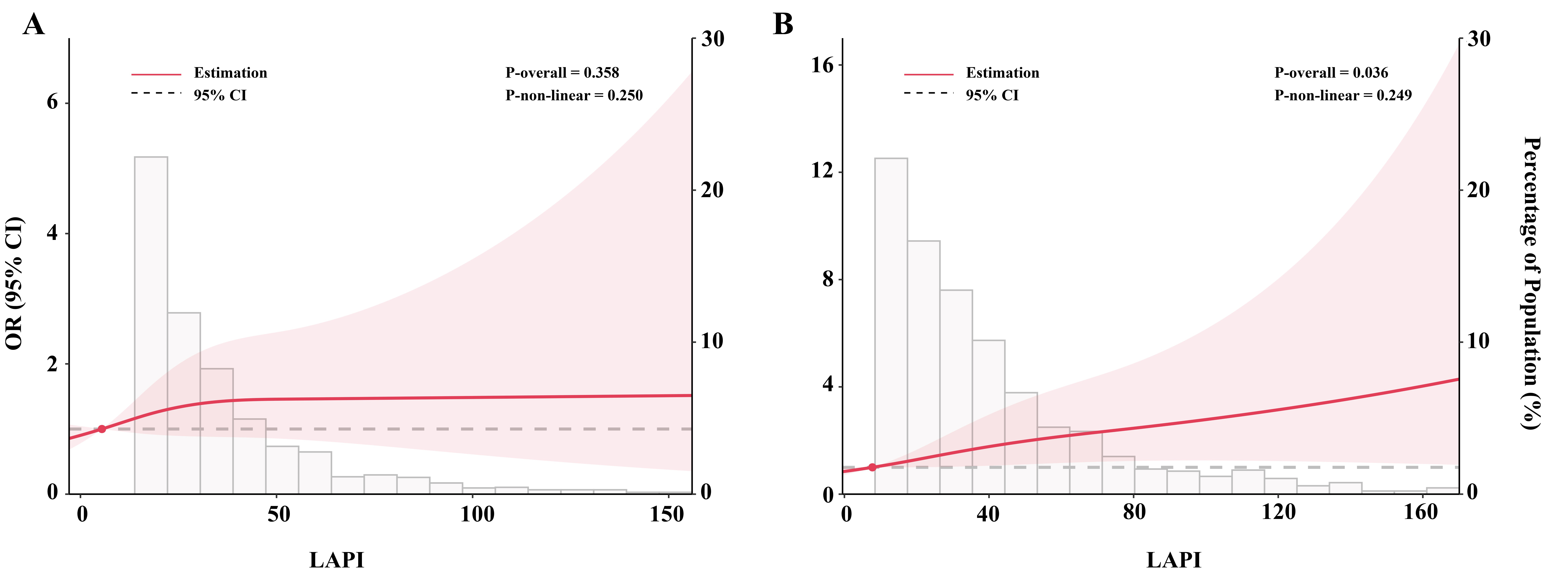
Supplementary Fig. 2. The dose-response association between LAPI and prevalent LUTS/BPH in participants with and without hypertension. Restricted cubic spline regression was used to investigate the dose-response relationship between LAPI and prevalent LUTS/BPH in participants without (A) and with (B) hypertension. Age, educational levels, marital status, sleep duration, afternoon nap, cigarette and alcohol consumption, depression, uric acid, LDL, BUN, HDL and total cholesterol were adjusted. The red line shows the odds ratio and the pink area shows the 95% confidence interval.

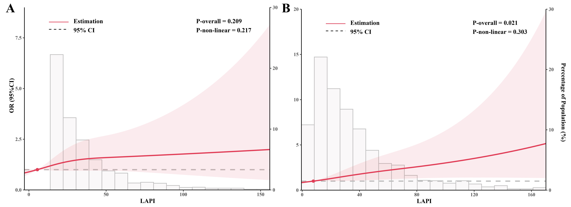
Supplementary Fig. 3. The dose-response association between LAPI and prevalent LUTS/BPH in participants with and without hypertension after interpolation. The missing values were first interpolated using random forest method. Then, restricted cubic spline regression was used to investigate the dose-response relationship between LAPI and prevalent LUTS/BPH in participants without (A) and with (B) hypertension. Age, educational levels, marital status, sleep duration, afternoon nap, cigarette and alcohol consumption, depression, uric acid, LDL, BUN, HDL and total cholesterol were adjusted. The red line shows the odds ratio and the pink area shows the 95% confidence interval.

